과목: 오픈소스기초설계
학번/이름: 20251766/설수현

- ex3-0
echo "MYENV is: $MYENV"
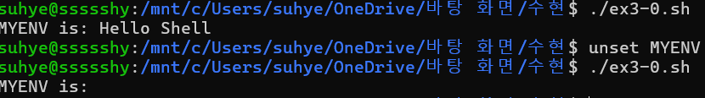

- ex3-1
a=$1
b=$2

echo "Add: $((a+b))"
echo "Sub: $((a-b))"
echo "Mul: $((a*b))"
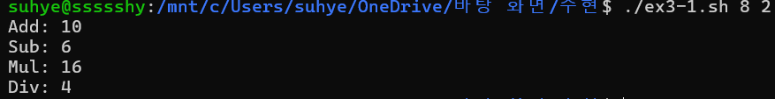
echo "Div: $((a/b))"

- ex3-2
while true
do
read -p "x값 입력(q=quit): " x
if [ "$x" = "q" ]; then break; fi
y=$(echo "0.5 * $x * $x" | bc -l)
echo "y = $y"
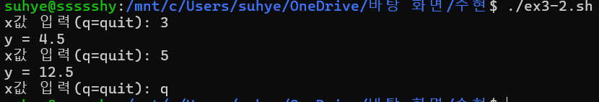
done

- ex3-3
subjects=("국어" "수학")

declare -A scores
sum=0
count=0

echo "과목 점수 입력"

for sub in "${subjects[@]}"
do
read -p "$sub 점수 입력: " s
scores[$sub]=$s

if [ $s -ge 90 ]; then
echo "$sub ($s점) → A"
else
echo "$sub ($s점) → B"
fi

sum=$((sum + s))
count=$((count + 1))
done

avg=$((sum / count))

echo "========================"
echo "평균 점수: $avg"

if [ $avg -ge 90 ]; then
echo "평균 등급: A"
else
echo "평균 등급: B"
fi
echo "========================"

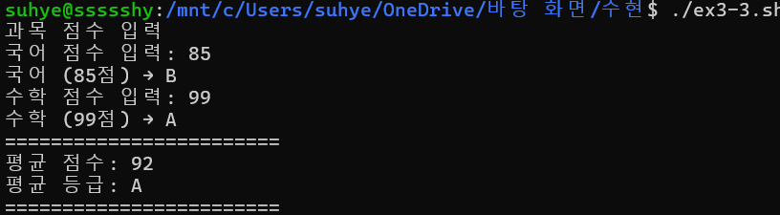

- ex3-4
scores=()
while true
do
echo "==================="
echo "1) 과목 성적 추가"
echo "2) 모든 점수 보기"
echo "3) 평균 점수 확인"
echo "4) 평균 등급(GPA)"
echo "5) 종료"
echo "==================="
read -p "> 선택: " sel

case $sel in
1)
read -p "점수 입력: " s
scores+=($s)
;;
2)
echo "점수: ${scores[@]}"
;;
3)
sum=0
for n in "${scores[@]}"; do sum=$((sum+n)); done
avg=$((sum/${#scores[@]}))
echo "평균: $avg"
;;
4)
if [ ${#scores[@]} -eq 0 ]; then echo "점수 없음"; continue; fi
sum=0
for n in "${scores[@]}"; do sum=$((sum+n)); done
avg=$((sum/${#scores[@]}))
if [ $avg -ge 90 ]; then echo "GPA: A"
else echo "GPA: B"; fi
;;
5)
echo "종료합니다."
break
;;
esac
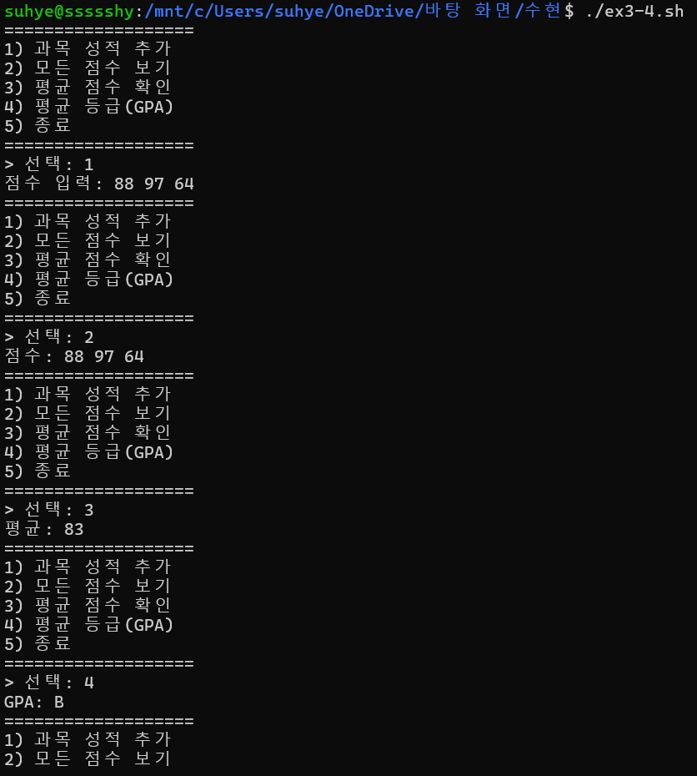
done

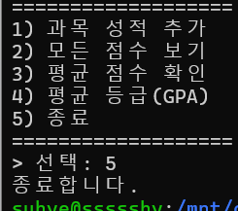

- ex3-5
run_cmd() {
eval "ls $1"
}

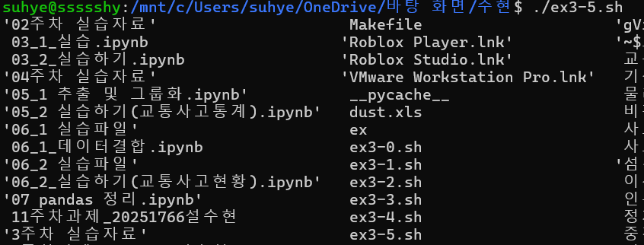
run_cmd "$1"

- ex3-6
1) 파이썬 파일 (test.py)
import sys

print("=== Start ===")
print("입력 인자:", sys.argv[1:])
print("=== End ===")

2) ex3-6.sh

python3 test.py "$@"
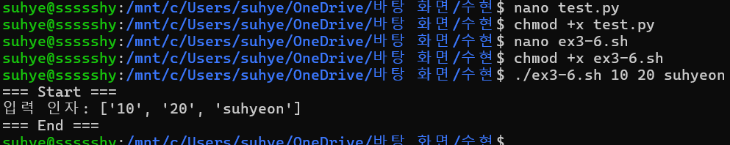

- ex3-7
while true
do
echo "1) 사용자 정보"
echo "2) CPU 사용률(top)"
echo "3) 메모리 사용량(free)"
echo "4) 디스크 사용량(df)"
read -p "> 선택: " s

case $s in
1) who ;;
2) top -n 1 ;;
3) free -h ;;
4) df -h ;;
esac
done

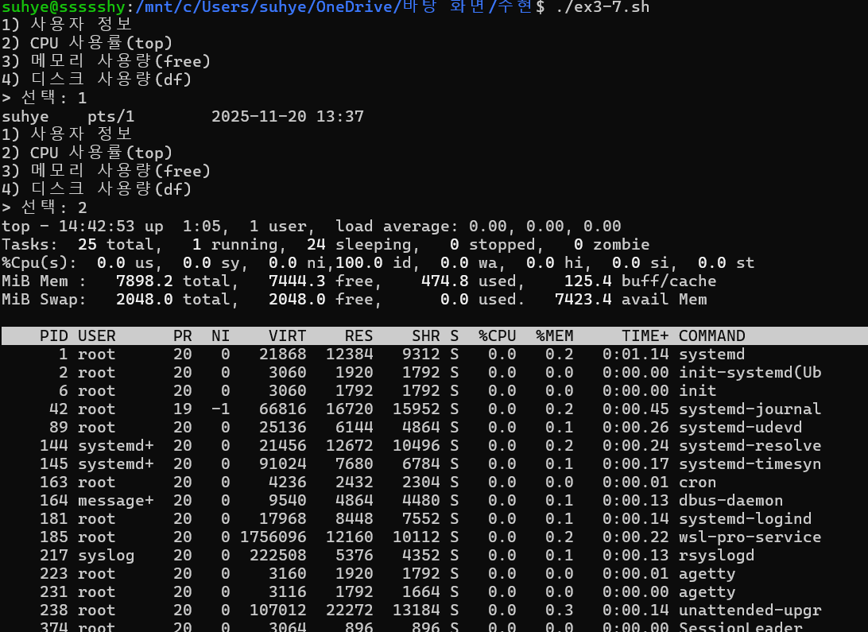
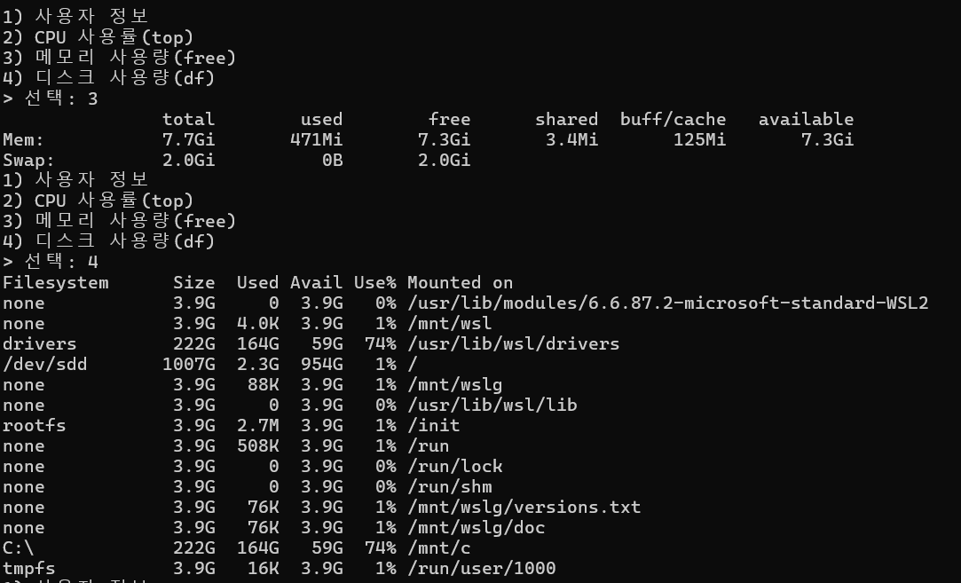

- ex3-8
if [ ! -d DB ]; then
mkdir DB
fi

cd DB
touch f1.txt f2.txt f3.txt f4.txt f5.txt

tar -czf db.tar.gz f*.txt
cd ..

mkdir -p train
for f in DB/f*.txt
do
ln -sf ../$f train/
done

echo "완료!"
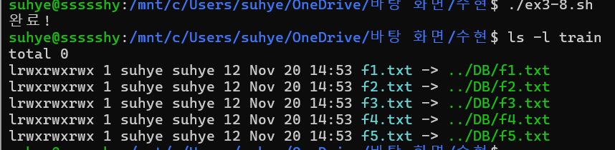

- ex3-9
DB=DB.txt
touch $DB

while true
do
echo "1) 팀원 정보 추가"
echo "2) 한 일 기록"
echo "3) 이름 검색"
echo "4) 날짜 검색"
echo "5) 종료"
read -p "> 선택: " s

case $s in
1)
read -p "이름: " name
read -p "전화/생일: " info
echo "이름:$name 정보:$info" >> $DB
;;
2)
read -p "날짜: " date
read -p "내용: " content
echo "날짜:$date 내용:$content" >> $DB
;;
3)
read -p "검색할 이름: " name
grep "이름:$name" $DB
;;
4)
read -p "검색할 날짜: " date
grep "날짜:$date" $DB
;;
5)
break
;;
esac
done

